https://github.com/MargusVol

Esimene Video

using System;

namespace ConsoleApp6

{

class Program

{

static void Main()

{

string UserChoice = string.Empty;

do

{

Console.WriteLine("Please enter your target?");

int UserTarget = int.Parse(Console.ReadLine());

int Start = 0;

while (Start <= UserTarget)

{

Console.Write(Start + " ");

Start = Start + 2;

}

do

{

Console.WriteLine("Do you want to continue? - Yes or No?");

UserChoice = Console.ReadLine().ToUpper();

if (UserChoice != "YES" && UserChoice != "NO")

{

Console.WriteLine("Invalid Choice, Please say Yes or No");

}

} while (UserChoice != "YES" && UserChoice != "NO");

} while (UserChoice == "YES");

}

}

}

Esimene Video

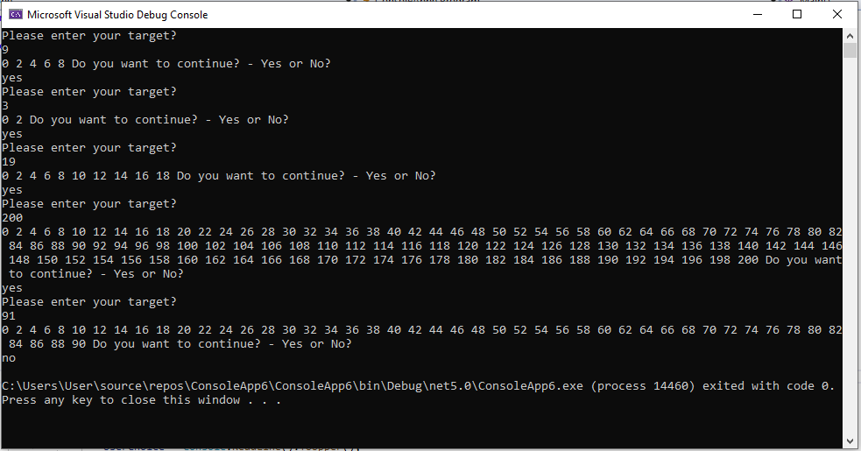

Teine & Kolmas Video

using System;

namespace ConsoleApp6

{

class Program

{

public static void Main()

{

Program.EvenNumbers(30);

Program P = new Program();

int Sum = P.Add(10, 20);

Console.WriteLine("Sum = {0}", Sum);

}

public int Add(int FN, int SN)

{

return FN + SN;

}

public static void EvenNumbers(int Target)

{

int Start = 0;

while(Start <= Target)

{

Console.WriteLine(Start);

Start = Start + 2;

}

}

}

}

Teine & Kolmas Video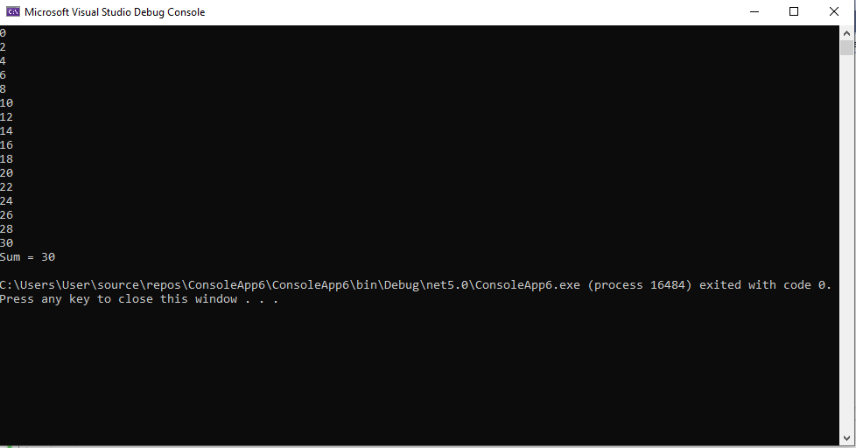

Neljas Video

using System;

namespace ConsoleApp6

{

class Program

{

public static void Main()

{

int[] Numbers = new int[5];

Numbers[0] = 101;

Numbers[1] = 102;

Numbers[2] = 103;

Numbers[3] = 104;

Numbers[4] = 105;

//ParamsMethod();

//ParamsMethod(Numbers);

ParamsMethod(Numbers);

}

public static void ParamsMethod(params int[] Numbers)

{

Console.WriteLine("There are {0} elements", Numbers.Length);

foreach(int i in Numbers)

{

Console.WriteLine(i);

}

}

}

}

Neljas Video